
LAB EXAM
Concepts of Programming & Operating System
Total Marks: 10 Time: 1 hour
Name : Funde Pandurang Gahininath

- Write a program to insert an element at a specified position into an array, without the loss of any values. The program should not throw exception, if the array is currently full. Instead, it should omit the last element of the array and shift all numbers to insert the element in the specified position.

package com.labexam.main;
import java.io.*;
import java.lang.*;
import java.util.*;
public class Labexam {
public static int[] addX(int n, int arr[], int x)
{
int i;
int newarr[] = new int[n + 1];
for (i = 0; i < n; i++)
newarr[i] = arr[i];
newarr[n] = x;
return newarr;
}
public static void main(String[] args)
{
int n = 10;
int i;
int arr[]
= { 1, 2, 3, 4, 5, 6, 7, 8, 9, 10 };
System.out.println("Initial Array:\n"
+ Arrays.toString(arr));
int x = 50;
arr = addX(n, arr, x);
System.out.println("\nArray with " + x
+ " added:\n"
+ Arrays.toString(arr));
}
}

Output:
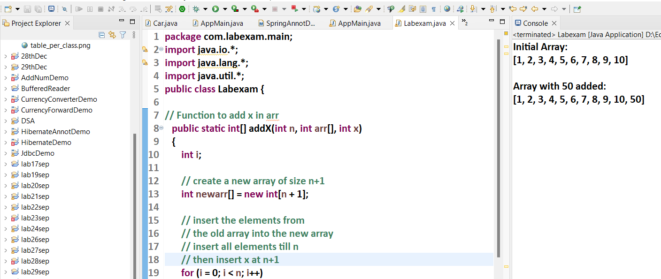

- Write a C program to create a Zombie process.


         

